Python Database Communication (PDBC)
Every application required to store or save data permanently.
This data can be saved permanently using 2 systems.
- File System
- Database System

Limitations of file system
- Files can hold large amount data
- Files are not secured because files are managed by operating system
- File system does not provides any query language

Advantage of database system
- Database can hold large amount data
- Data stored inside database is secured, this security is provided database manage system
- Database system provides a query language (SQL)

Database applications or database software’s
- MySQL 🡺 Oracle Corporation
- Oracle 🡺 Oracle Corporation
- SQL Server 🡺 Microsoft
- PostgreSQL 🡺 Postgres
- Mongodb (no-SQL) 🡺 Mongo
- SQlite 🡺 PSF (python software foundation)

Database understands only one language, SQL (Structured Query Language).
SQL provides set of commands to perform operations on database
Based on the types of operations, these SQL commands are classified into different categories

- DDL (Data Definition Language)
  - Create
  - Alter
  - Drop
- DML (Data Manipulation Language)
  - Insert
  - Update
  - Delete
- DRL (OR) DQL (Data Query Language)
  - Select
- TCL (Transaction Control Language)
  - Commit
  - Rollback
- DCL (Data Control Language)
  - Grant
  - Revoke

Installing MySQL Database

https://dev.mysql.com/downloads/installer/

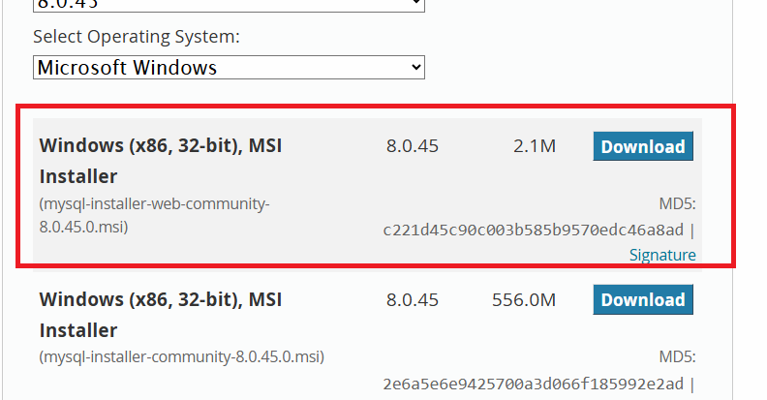

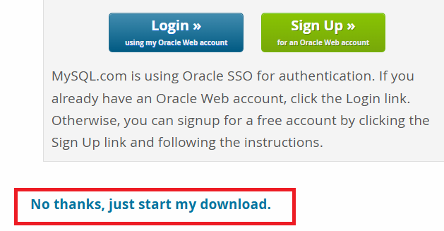

Open mysql command line client
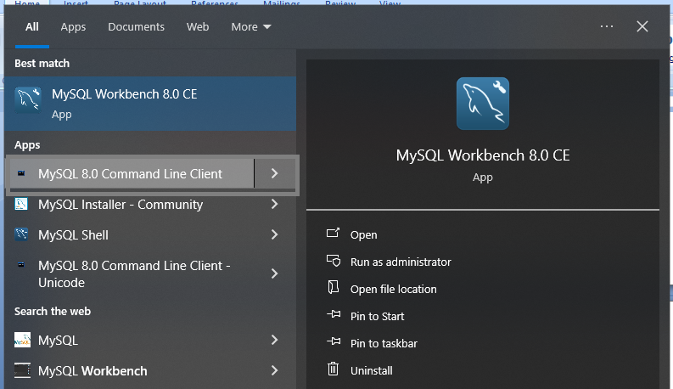
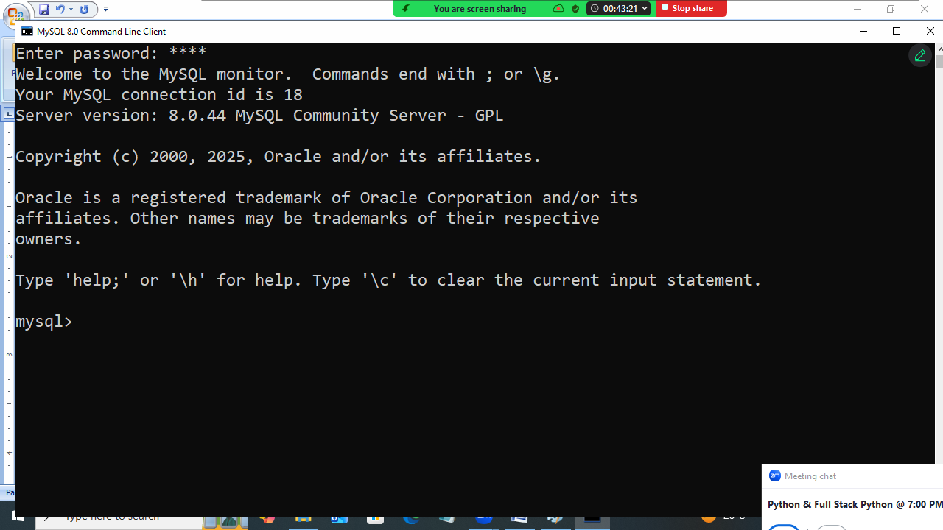

How to create database?
Database is created using “create” command.

Syntax:
create database database-name

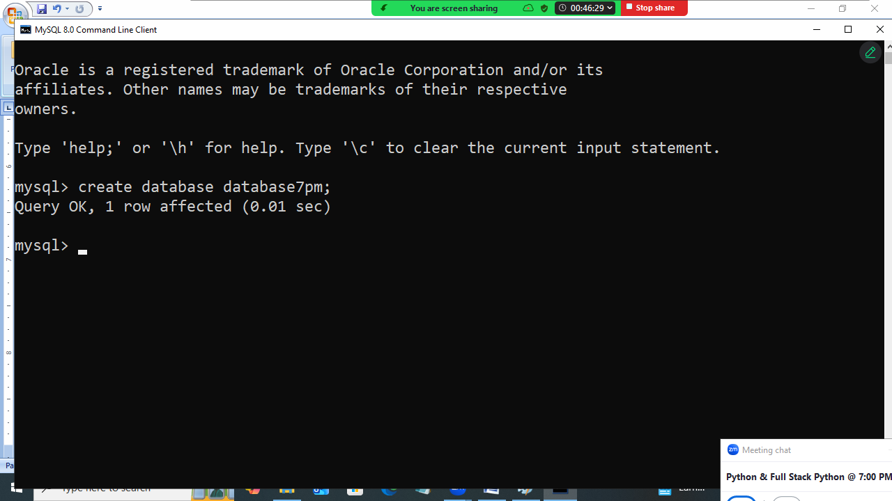

How to list databases created?
Show databases
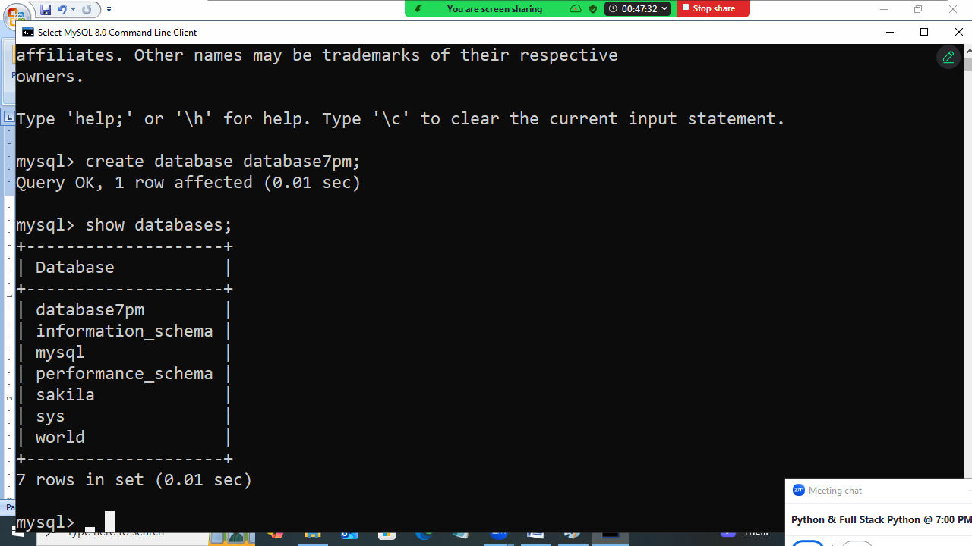

Within database data is organized inside tables.
How to create table?
ceate table <table-name> (column-name datatype,
column-name datatype,
Column-name datatype,…)

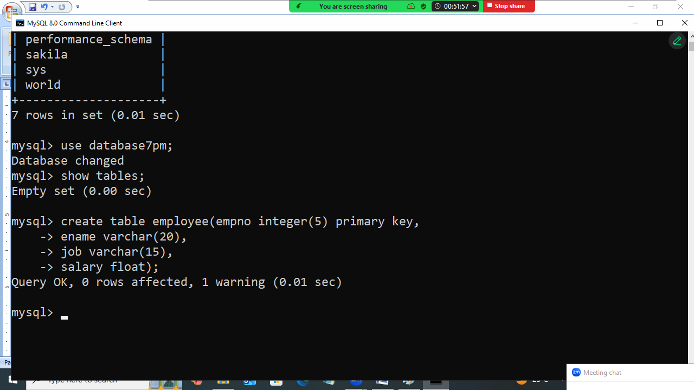

How list tables exists within database?
Show tables
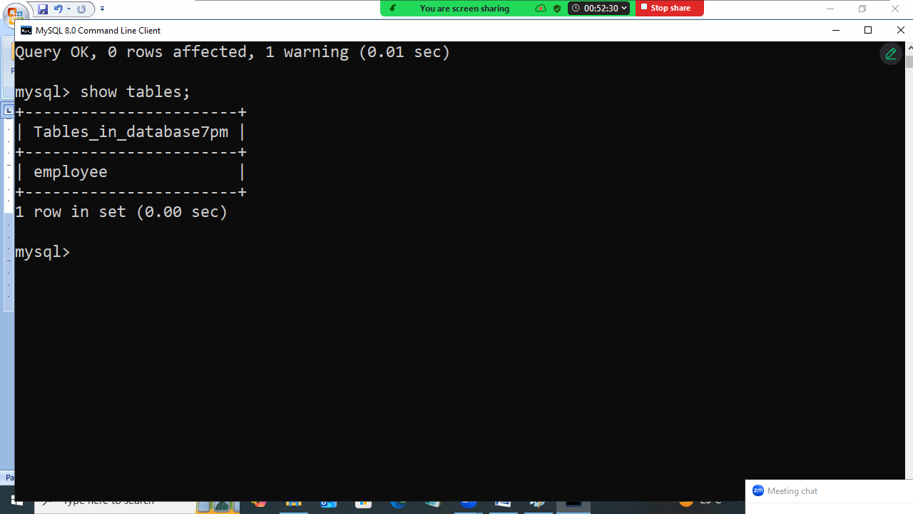

How to insert data within database table?
“INSERT” command is used for inserting values within database table

Syntax:
Insert into table-name values(value-of-col1,value-of-col2,…)

Syntax:
Insert into table-name(col1,col2,col3,) values (value-of-col1,value-of-col2,…)

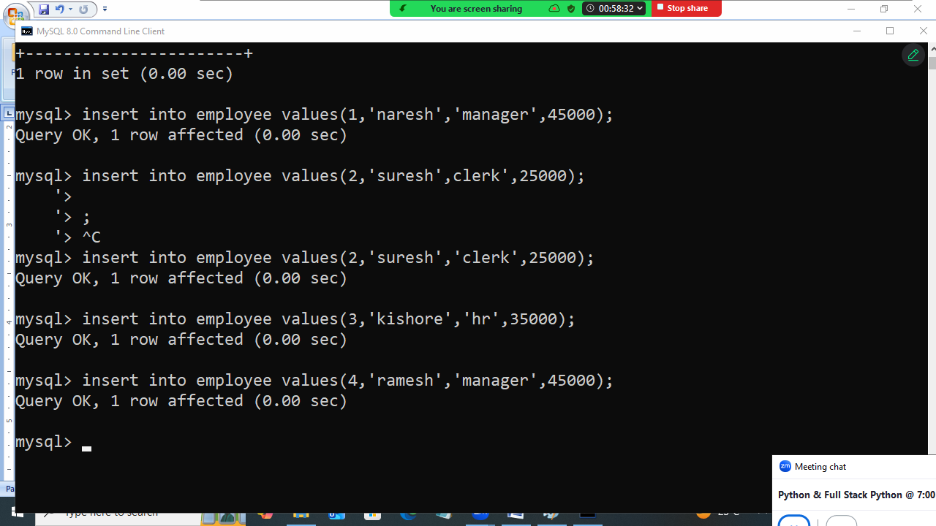

How to read data from database table?
“SELECT” command is used for reading data from database table.

SELECT * from table-name
SELECT column-name,column-name from table-name
SELECT * from table-name where condition

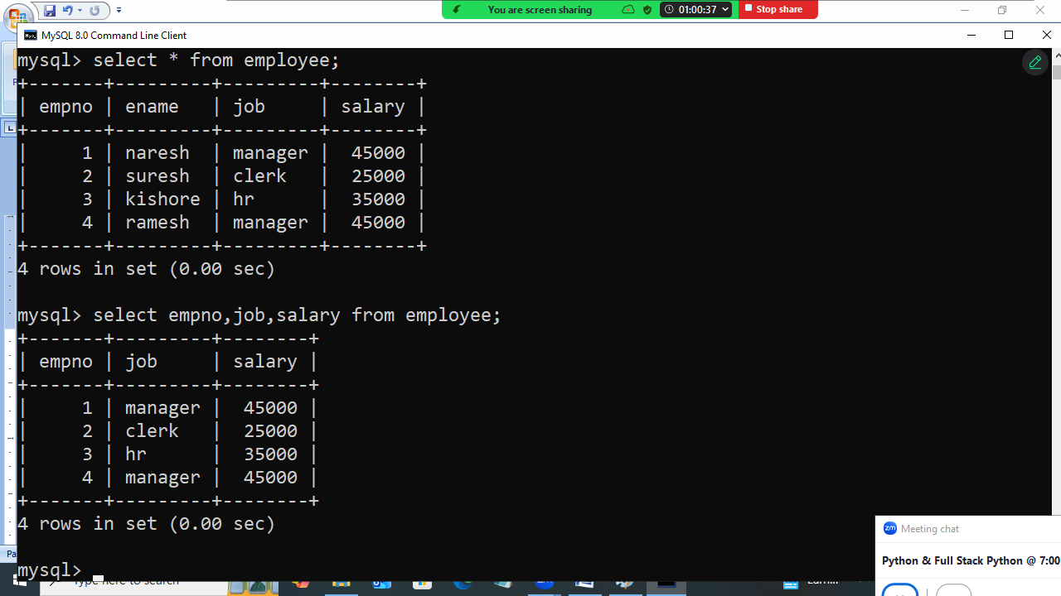

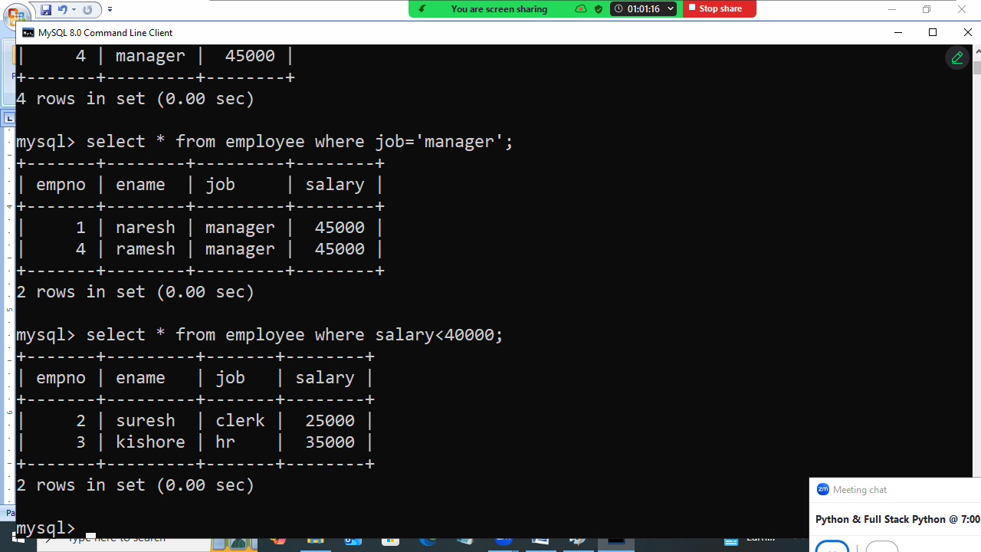

Update command
This command is used for replacing values within database table.

Syntax:
Update <table-name> set column-name=value where condition
Update <table-name> set column-name=value,column-name=value where condition

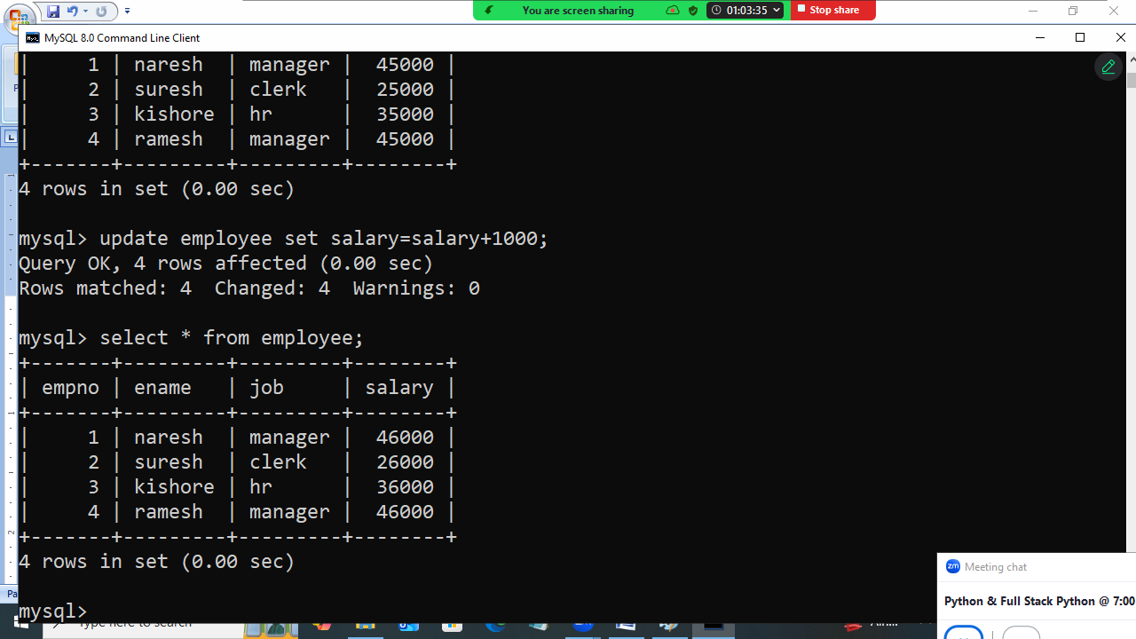
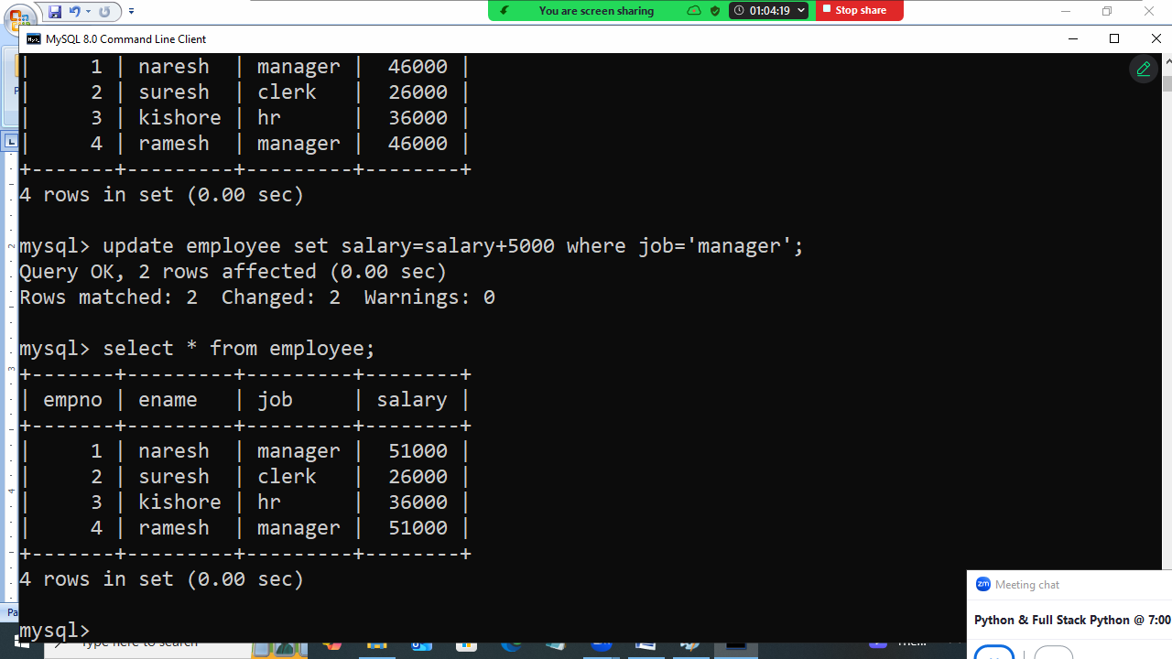

DELETE command
This command is used to delete rows from database table

Syntax:
Delete from table-name; 🡪 delete all rows
Delete from table-name where condition; 🡪 delete only rows based on condition

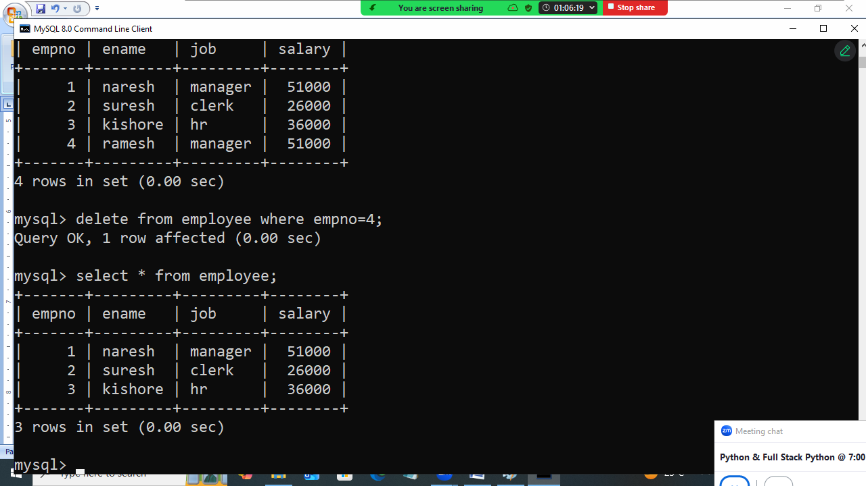

Python and MySQL communication

In order to communicate with any database by python program it required drivers or libraries.
Each database vendor provided one library to communicate with databases.

Database | Libraries/Driver
Mysql | Mysql-connector-python
Oracle | Cx_Oracle (OR) oracledb
SQLite | Sqlite3
SQL Server | pymssql
Mongodb | Pymongo
PostgreSQL | psycopg

In order to communicate mysql database, install mysql-connector-python

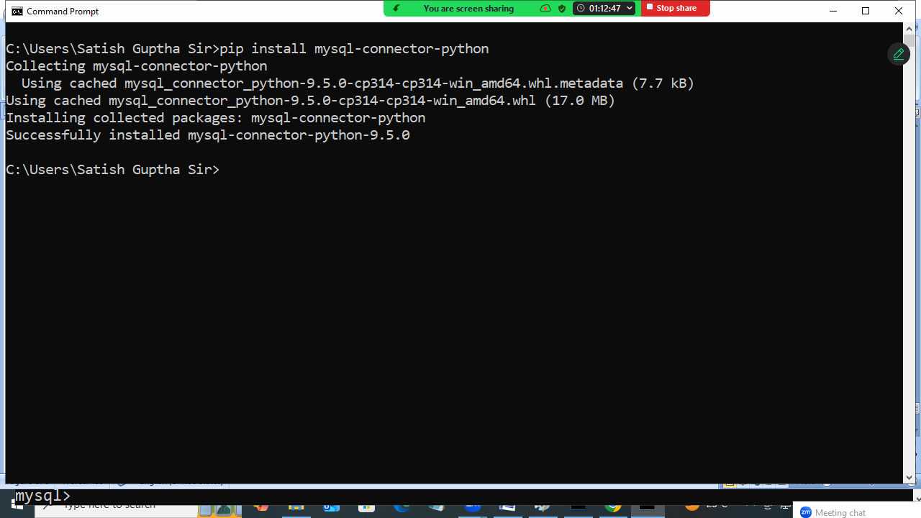
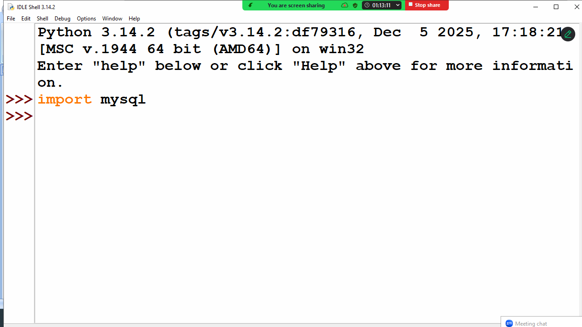

Basic steps to communicate with database
- Establish connection to database
- Create cursor object for sending SQL statements
- Send SQL statements using cursor object
- Read result stored inside cursor object
- Close connection

Establishing connection to database
mysql.connector.connect() function is used to establish connection to database.

Syntax:
connect(database,user,password,host,port)

database 🡺 database name
user 🡺 database user name
password 🡺 database password
host 🡺 ip-address of system where database is running
port🡺 database server portno

default portno of mysql is 3306

Example:
# Write a program to establish connection to database

import mysql.connector

cn=mysql.connector.connect(database="database7pm",
user="root",
password="root",
host="localhost",
port="3306")
print("Connection is Established")

Output
Connection is Established

Cursor object
Cursor object is used for sending SQL statement to database

How to create cursor object?
connection-object.cursor()

cursor object provide the following methods for sending SQL statements to database
- execute()
- executemany()

execute()
This method is used for sending SQL statements to Database.
Database receives SQL statement , process it and generate result. This result is written inside cursor object.

# Write a program to create table within database

import mysql.connector

cn=mysql.connector.connect(database="database7pm",
user="root",
password="root",
host="localhost",
port="3306")
c=cn.cursor()
SQL='''create table student(rollno integer primary key,
name varchar(20),
course varchar(20))'''
c.execute(SQL)
print("Table Created")
cn.close()

Example:
# Write a program to insert data into student table
import mysql.connector
cn=mysql.connector.connect(database="database7pm",
user="root",
password="root",
host="localhost",
port="3306")
c=cn.cursor()
SQL="insert into student values(%s,%s,%s)"
while True:
rollno=int(input("Rollno:"))
name=input("StudentName:")
course=input("StudentCourse:")
c.execute(SQL,params=(rollno,name,course))
print("Student Created")
ans=input("Add another student?")
if ans=="no":
cn.commit()
break
cn.close()

Output
Rollno:1
StudentName:naresh
StudentCourse:python
Student Created
Add another student?yes
Rollno:2
StudentName:suresh
StudentCourse:java
Student Created
Add another student?yes
Rollno:3
StudentName:kishore
StudentCourse:c++
Student Created
Add another student?no

